# **Comparing Different Types of Symbolic Execution Techniques**

## **Abstract:**

* Aim
* How we’ve put some techniques into practice ?
* How our results are reflective of the effectiveness or lows of the implemented techniques
* Everything generalized (with no details)
* Touch every part and provide emphasis on comparison and implementation.

## **Introduction:**

* What is Symbolic Execution ?
* Different types of Symbolic Execution
* Why choose symbolic execution over other alternatives ?
* What is our focus ?

## **Design Principles for Symbolic Executors:**

* Progress
* Work repetition
* Analysis reuse

## **Types of Symbolic Execution in focus:**

1. **Static Symbolic Execution**

* Explanation
* Examples
* Pros
* Cons
* Industry Applications

1. **Selective Symbolic Execution**

* Explanation
* Examples
* Pros
* Cons
* Industry Applications

1. **Dynamic Symbolic Execution**

Avoid using the constraint solver for complex operations

* **Breadth-first-style symbolic execution**
* Explanation
* Examples
* Pros
* Cons
* Industry Applications
* **Depth-first-style symbolic execution**
* Explanation
* Examples
* Pros
* Cons
* Industry Applications
* Some more search techniques:

1] Random Search

2] Generational Search

3] CarFast

4] CFD

5] FGS

6] CGS

7] RWset

8] Veritesting

* General Description
* Table comparing all search strategies:

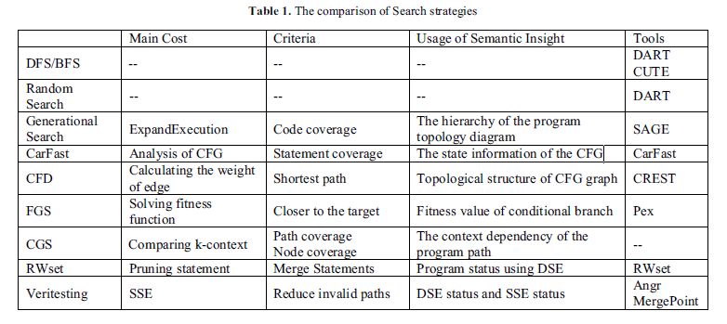

1. **Backward Symbolic Execution**

* Explanation
* Examples
* Pros
* Cons
* Industry Applications